Creating functions

Workshop #3

Flutter Developer Bootcamp

# **Purpose**

This workshop demonstrates the use of functions in Dart, including defining, returning values, and passing arguments.

**Problem**

In the given workshop demonstrates the fundamental concepts of function definitions and function calls. In Dart, the main() function serves as the entry point of the application. Within main(), function2() is called to retrieve and print a specific string, demonstrating how functions can return values. Additionally, function3() showcases how functions can accept parameters and perform actions with them, in this case, printing a given string to the console. Together, these examples highlight the basic structure and usage of functions in Dart programming, essential for organizing and executing code effectively.You need to print message ‘Its just a function’ in void function1().

**How to Solve**

1. Checkout the workshop from Git Repo:

git clone -b <user-branch> <repo-URL>

1. Open the root folder inside VS Code
2. Open the root folder in terminal
3. Run the command dart run filename.dart
4. Createfunction1() is defined with void return type to print "It's just a function".
5. function2() returns a specific string 'This is returned string'.
6. function3(String str) accepts a string parameter and prints it.
7. Go To File: <specific-file--method> à <method-name>, implement your logic.

**You will Achieve**

When you complete this workshop you will learn the following:

**Methods and Functions Used:**

* **Main Function (main()):**
* Entry point of the Dart program.
* Calls function2() to demonstrate returning a string value and printing it.
* Calls function3() to show passing a parameter (string) and printing it.
* **Function2 (function2()):**
* Illustrates a function that returns a string value.
* Returns the string 'This is returned string'.
* **Function3 (function3(String str)):**
* Demonstrates a function that accepts a string parameter and prints it.
* Prints the string received as the parameter.
* **Function1 (function1()):**
* Added function to print a specific message.
* Prints the message "It's just a function".

# **Screenshots**

## **Before implementation (without creating void function1)**

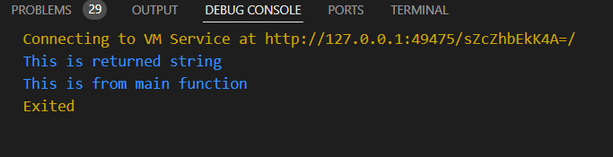

## **After implementation (with creating void function1)**

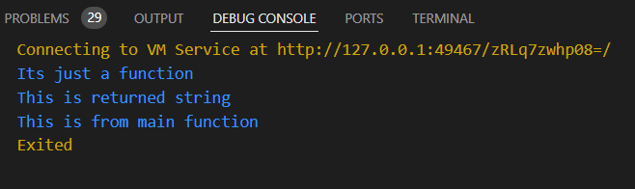

# **How to submit your workshop**

Push your project back to the same git branch using command:

<command name>

# **Happy Coding!**